Project 3: Student Class List

# Problem

Write an application which stores the courses taken by a student and prints out a report. Data will be read from a data.txt file. Once all data has been read from the data.txt file, your program should print a report as shown in the Program Output section below. After the list of courses has been printed, you should then calculate and display the cumulative GPA of all courses in the list.

## Important Constraints

1. You must implement a linked list as the underlying data structure.
2. Course entries will be stored in the linked list structure.
3. This must be done using classes and objects in OOP style. Each class will be in a separate module (see below) and the application code that reads the data from the data.txt file will be in file main.py.

# Course ADT (course.py)

You will implement a Course ADT which implements the following methods:

* constructor: must have default values for all parameters and must validate all parameters.
* number(): retrieve Course Number as an integer
* name(): retrieve Course Name as a string
* credit_hr(): retrieve Credits as a floating-point number
* grade() : retrieve Grade as a numeric value in range 4.0 – 0.0
* __str__ (): returns a string representing a single Course as shown in the Program Output section
* The courses taken by the student will be provided in a data file. You will have to parse the data from that file and store it in a Linked List of courses.

# CourseList ADT (courselist.py)

Your CourseList ADT must use a Linked List implementation. The course list must be able to hold an **unlimited** number of Courses. The CourseList ADT implements the following methods:

* constructor to initialize all needed data for an empty list
* insert(Course): insert the specified Course in Course Number ascending order
* remove(number): remove the first occurrence of the specified Course
* remove_all(number): removes ALL occurrences of the specified Course
* find(number): find the first occurrance of the specified course in the list or return -1
* size(): return the number of items in the list
* calculate_gpa(): return the GPA using all courses in the list
* is_sorted(): return True if the list is sorted by Course Number, False otherwise
* __str__(): returns a string with each Course’s data on a separate line (as shown in the Program Output)
* __iter__() and __next__(): the linked list must be iterable

# Program Output

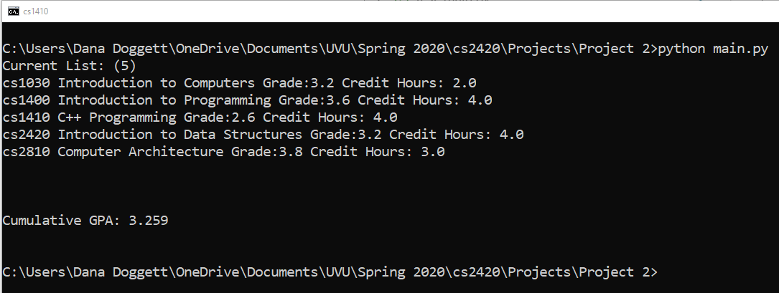

Figure 1. Example Program Output

# Grading (100 points)

pylint will be run on corse.py and courselist.py. Expected minimum score for each file is 8.5.

Score is the sum of:

* + Percentage of test cases passed x 80 points
  + min(Coding style score/8.5, 1) x 20 points
  + Possible adjustment due to physical inspection of the code, to make sure  
    you actually implemented things.

# What to Submit in Canvas

* main.py (driver file)
* course.py
* courselist.py
* A link to a short video showing results of your code running, 1 minute max.  
  Post the video on Youtube, for example, with a unlisted link, and submit the link in comments to your submission.